**AIT-524, Class 04, Practice Problems**

**Tanmoy Chowdhury, G01025893**

As in Crow’s Foot symbol mention everything so I ignored to describe in words.

**Practice Problem 01:**

**Solution:**

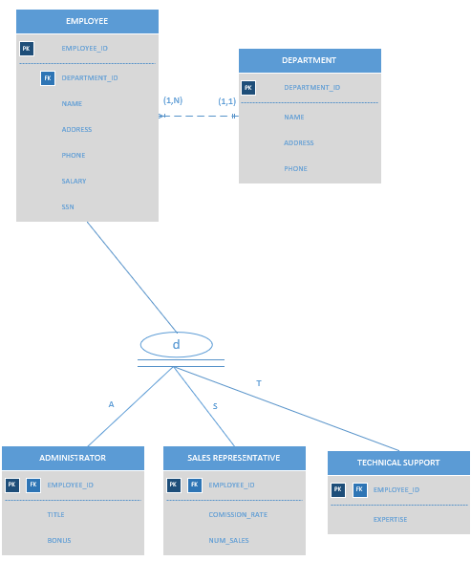

**Practice Problem 02:**

**Solution:**

